**TUT-2**

­­­­­NAME-SANCHIT JAIN

BATCH-B-7

ENROLL-21103192

**Ques.1)**

All 1, 2, 3 statements are true.

REASON :

New is an operator but malloc() is a function.

New calls constructor but malloc() doesn’t.

New returns exact data type and malloc() returns void*.

**Ques.2)**

#include<iostream>

using namespace std;

int main(){

    cout<<"Enter number of subjects :"<<endl;

    int n;

    cin>>n;

    int *marks = new int[4];

    for(int i=0;i<n;i++){

        cout<<"enter marks of subject :"<<i+1<<endl;

        cin>>*(marks+i);

    }

    cout<<"Displaying the details"<<endl;

    for(int i=0;i<n;i++){

        cout<<"Marks of subject are :"<<marks[i]<<endl;

    }

    delete [] marks;

    return 0;

}

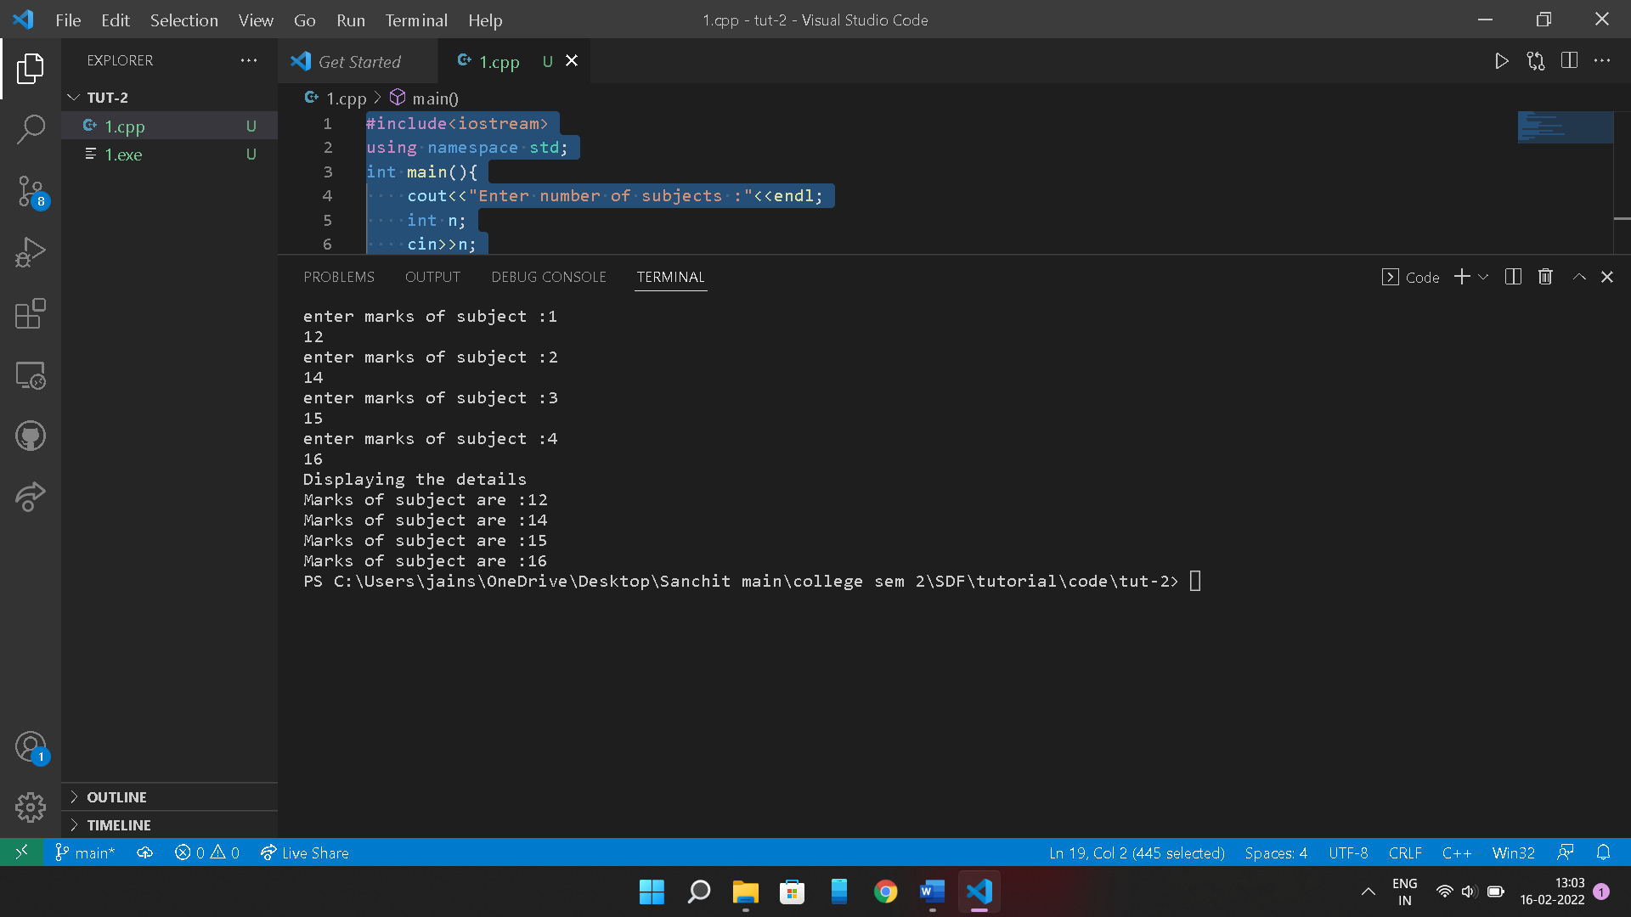

**Ques4)**

OUTPUT :

129, a

Reason : *ptr=&a means ptr is a pointer storing address of a.

&cho means cho is a reference variable to ch .

This is also called aliasing.

Then cho =cho +a ,so cho =65 +32= 97 .

Hence, ch is now 97 i.e. ch= ‘a’. *ptr =*ptr +ch ,so *ptr= 32 +97 =129

So, 129, a is printed

**Ques5)**

OUTPUT :

10, 20, 30, 40, 50,